GPP Session 9

Stakeholder Layers

ESTIMATED SESSION TIME
- 45 minutes

OBJECTIVES
By the end of this session, participants will have:
- Identified best strategies for engaging different types of stakeholders.
- Increased their understanding of why stakeholder engagement is important in the research process.

METHODS
- Small group work
- Large group discussion

MATERIALS REQUIRED
- Examples of Stakeholders
- Flip chart
- Markers
- Tape

TO PREPARE FOR THE SESSION
- Read through the entire training session and ensure that you are comfortable with its content and methodologies.
- Prepare a copy of the Examples of Stakeholders handout (see Session 9 Materials below) for each participant or small group.
- Prepare the Examples of Stakeholders chart and questions listed under Step 3 (below) for display on a slide or flip chart.
- Review the Examples of Stakeholders chart and the related content in Section 1 of the GPP guidelines.

TO CONDUCT THE SESSION
Step 1:
- Explain to participants that you will be discussing the different types of stakeholders and their corresponding engagement activities in an HIV biomedical prevention trial.
- Display the Examples of Stakeholders diagram, and ask participants to reflect on the types of stakeholders that exist for their trial site.

Step 2:
- Divide participants into four groups.
- Give each group a copy of the Examples of Stakeholders handout, and assign a layer of the chart to each group.

Step 3:
- Have each group come up with an example of a stakeholder from the layer they have been assigned who’d be likely to be engaged in a HIV biomedical prevention trial.
- Have them discuss the nature of their stakeholder’s potential involvement and then write up a detailed description or illustrative scenario of the engagement activities for presentation to the large group.
- Have participants discuss the following questions in their small groups (display the questions on a flip chart or slide):
- Why is your stakeholder important? How does your stakeholder influence the trial? What aspects of the research is the stakeholder involved in?
- What level of engagement does your stakeholder require from your research team?
- On which of the topic areas in Section 3 of the GPP guidelines will your stakeholder provide input?
- What is your strategy for involving the stakeholder? What are some examples of specific engagement activities?
- What are the short-term objectives of your engagement strategy?
- What is the potential long-term impact of this stakeholder’s involvement in biomedical HIV prevention research?

Step 4:
- Ask each group to make a brief presentation, describing their stakeholder and summarizing their responses to the questions above. Allow approximately five minutes for each group’s presentation.

Step 5:
- Close the session by summarizing a few key points from the discussion.
- Emphasize that every biomedical HIV prevention trial will involve different types of stakeholders and that it’s the research team’s responsibility to identify stakeholders who are relevant to their trial and develop effective strategies for engaging them.

Session 9 Materials

Examples of Stakeholders

Examples of Stakeholders

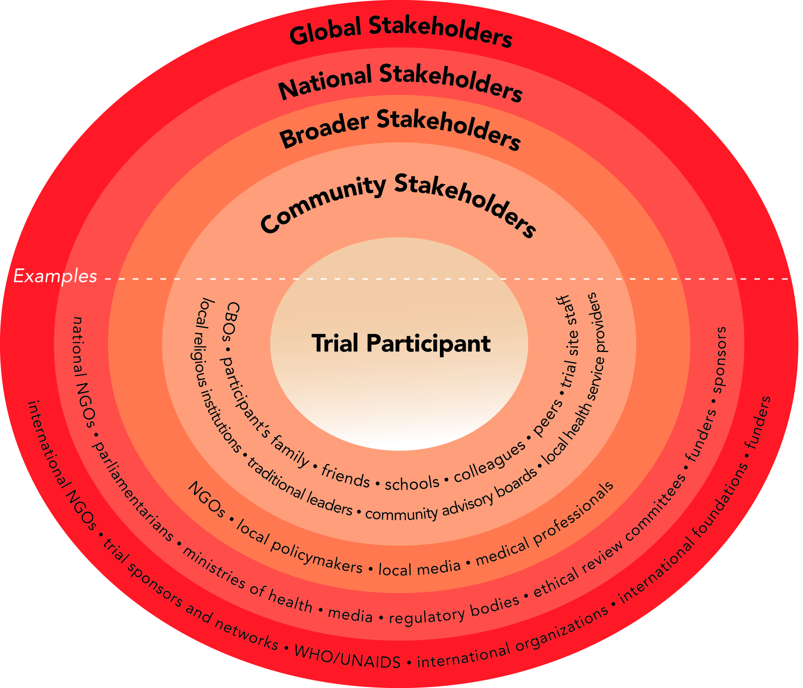

Various stakeholders may influence or be affected by a biomedical HIV prevention trial. Stakeholders include trial participants and other community stakeholders, in addition to a broader range of local, national, and international stakeholders.

